Using dnf1. Attempt to run the command gnuplot. You should find that it is not installed.

  
2. Search for the plotting packages.

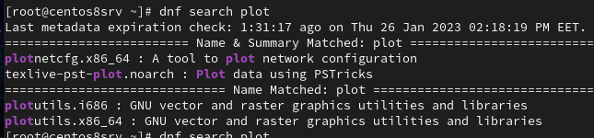  
3. Find out more information about the gunuplot package.

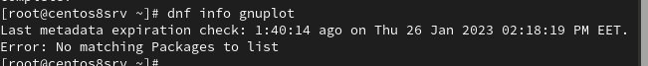   
4. Install the gnuplot package.

5. Attempt to remove the gnuplot package, but say no

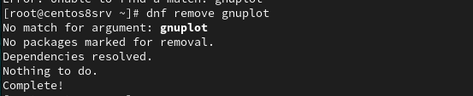  
6. How many packages would be removed  
No packages will be removed.

7. Attempt to remove the gnuplot-common package but say no

8. How many packages would be removed

No packages will be removed.  
9. Create the file /etc/yum.repos.d/cdrom.repo to enable install from the iso of Red Hat  
10. Try to install any package from the new repository  
Using rpm11. List all installed packages in your system.  
12. View the files in the initscripts package  
13. Get general information about bash rpm.  
14. Have the files from the pam package changed since it was installed.  
15. Which installed packages have gnome in their names?  
16. Install any uninstalled package from RH Enterprise Linux cds.  
17. Search for software resemble the Photoshop software other than Gimp and install it